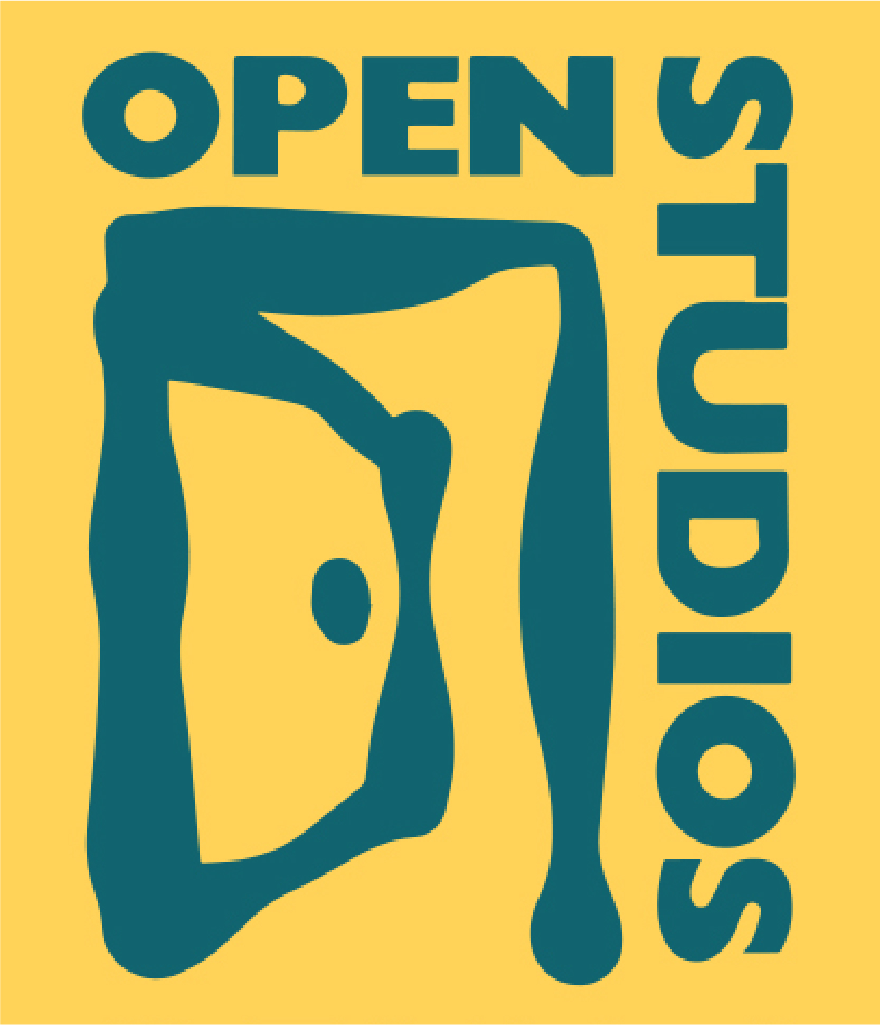
For Immediate Release

Contact: Caren Paul, Participating Artist
caren@gofarfast.com | 303-579-6777

Open Studios of Boulder is celebrating the 26th year of the Open Studios Tour. This year’s Tour of artist studios promises to be among the best ever with nearly 140 juried artists participating. The Tour is free of charge, open to the public the first three weekends of October, and is appropriate for all ages.

From its beginning in 1995, Open Studios has set rigorous standards for the Tour and its participating artists. During the Tour, artists display work that they offer for sale, are available to talk with patrons, and also provide an educational display or demonstration to help visitors understand their practice and inspiration. The Tour takes place Saturday and Sunday, noon to 5:00 pm – October 3, 4, 10, 1, 17 and 18.

Patrons can utilize the Tour Catalog/Map – available both on-line and in hard copy – to pick which artists to visit. This year, catalogs are available for free at the PBH Community Center. The listings show an image of each artist’s work along with a studio number and location that is cross-referenced to the included map. Additionally each studio uses Open Studio street signs to guide visitors to their location. Hundreds of these signs can be spotted in almost every neighborhood, so passer-bys can spontaneously drop-in on studios.

One Pinebrook Hills resident is on the Tour this year - Caren Paul on Pine Needle Road welcomes all Pinebrook residents to come visit her home art studio. Caren uses both watercolor and acrylic media to create colorful, vivid and bold images - sometimes representational, other times more abstract, but always inspired by the natural world. She will have both original and reproduction work available for sale, but especially hopes to inspire others to create and participate in Boulder’s many community art opportunities - especially Open Studios! She would love to see more PBH artists involved in next year’s Tour. She is currently exhibiting at R Gallery and Pop Gallery in Boulder, as well as in the Louisville Art Association Annual Fine Art Show. She will also be showing her work at Boulder Mountain Handmade at the Elks Lodge on Nov. 9-10.

The Open Studios Tour kicks off Friday, Oct. 3rd, 6 - 8:30 pm with the “Preview Exhibit,” a gallery show featuring one piece of art by each artist, and hosted this year at The Museum of Boulder, 2205 Broadway in Boulder. The Preview Exhibit will be open daily from 10 am - 5 pm, Oct 4 - 18, and is also a great way to create a self-guided studio tour. All artworks on display are for sale.

For more information: www.OpenStudios.org or call Caren at 303.579.6777, caren@gofarfast.com.

